* <https://docs.microsoft.com/en-us/azure/role-based-access-control/overview>
* Give user the lease amount of permissions to the users to get the work done.
* You can assign see and create role from Access Control (IAM) from from the resource.
* 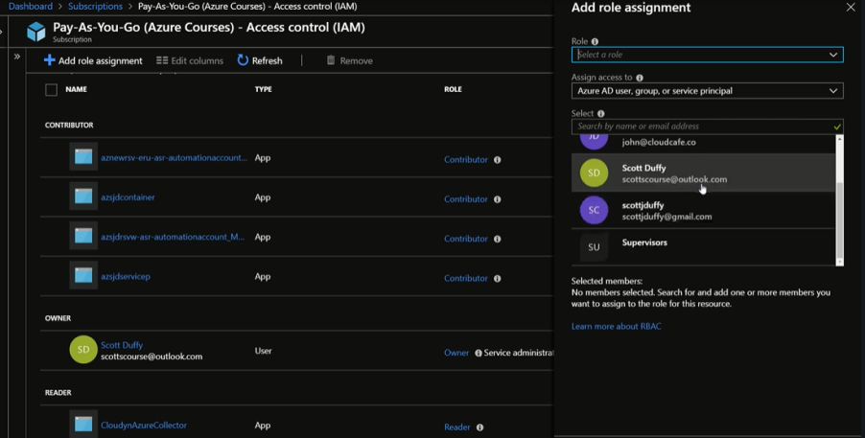
* Select a role from role drop down.
* Select a specific role assignment to the user for more secure and granular system.